2
Managing PowerShell 7
in the Enterprise
This chapter covers the following recipes:
- Utilizing Windows WindowsPowerShell Compatibility
- Installing RSAT Tools
- Exploring Package Management
- Exploring PowerShellGet and the PS Gallery
- Creating and using a local repository
- Establishing a code signing environment
- Working with Shortcuts and PSSHortCut module
- Working with Archive files
- Searching for files using Search Everything

Introduction
For an IT Professional in an Enterprise environment (and even in smaller ones), PowerShell 7 provides a platform to manage your environment. Many of the commands you need to carry out typical operations come with PowerShell 7, augmented by the commands provided with Windows Server feature tools. In addition, you can obtain third-party modules to extend your capabilities.
Automation, today, means using commands that come from many sources. Some are built-in, but there are gaps. Those gaps can be filled by modules you can obtain from the community and via the PowerShell gallery. In many cases, you can make use of .NET and WMI classes. When all else fails, there is often a command-line tool.
As you blend these tools into your workflow, you need to be aware of how a given set of commands work as well as the objects returned. You also need to deal with the mismatch. The Get-ADComputer command, for example, returns the name of thae a computer in AD in the Name property. Most commands that interact with a given computer, use the parameter ComputerName.
In building Windows Server 2022, Microsoft did not update most of the role/feature management tools to support PowerShell 7. These tools work natively in Windows PowerShell but many do not work directly in PowerShell 7. The reason for this is that Microsoft based Windows PowerShell on Microsoft’s .NET Framework, whereas PowerShell 7 is based on the open-source .NET. The .NET team did not port all the APIs from the .NET Framework into .NET. Thus many of the role/feature commands that you can run in Windows PowerShell do not run natively since .NET did not implement certain .NET Framework.
To get around this, PowerShell 7 comes with a Windows PowerShell compatibility solution. When you attempt to use some of the older commandsd (i.e. those that live in the System32 Windows directory), PowerShell 7 creates a PowerShell remoting session on the current host based on a Windows PowerShell 5.1 endpoint. Then, using implicit remoting, PowerShell creates and imports a script module of proxy functions that invoke the underlying commands in the remoting session. This enables you to use commands, such as Add-WindowsFeature, more or less seamlessly. You examine the Windows PowerShell compatibility feature in Utilizing Windows PowerShell Compatibility.
Most Windows Server 2022’s features and roles provide management tools you use to manage the role or feature. You can also install and use these feature tools on any host allowing you to manage features across your network as you can see in Installing RSAT tools.
You can also find and utilize third-party modules that can improve your PowerShell experience. PowerShell implements a set of built-in package management commands, as you can see in Exploring Package Management.
Some organizations create their own private package repositories. These enable their organizations to share corporate modules inside the corporate network. You create a new package repository in the Creating and using a local package repository recipe.
PowerShell 7, like Windows PowerShell, supports the use of digitally signed scripts. You can configure PowerShell to run only properly signed scripts as a way of improving the organization’s security. It is straightforward to establish a code-signing environment, using self-signed certificates, as you investigate in the Establishing a code-signing environment recipe.
To simplify the use of commands in an interactive environment you may find it convenient to create shortcuts you can place on the desktop or in a folder of shortcuts. In Working with shortcuts and the PSShortCut module, you manage shortcuts.
A common problem that can face when automating your environment is the management of archive files. As you saw in Installing Cascadia Code font, you can often get components delivered as a ZIP file. In Working with Archive files, you examine commands for managing these files.
Windows, Windows Server, and Windows applications have grown significantly both in scope and the files that support them. Sometimes finding key files you need can be challenging, especially on larger file servers.

System used in the chapter
This chapter is all about getting you started with PowerShell 7 – installing and configuring your environment to make the most out of PowerShell 7. In this chapter, you use a single host, SRV1, as follows:
Figure 2.1: Host in use for this chapter
Insert image B18878_02_01.png
In later chapters, you will use additional servers and will promote SRV1 to be a domain-based server rather than being in a workgroup.

Utilizing Windows PowerShell Compatibility
The PowerShell 7 Windows Compatibility solution allows you to use older Windows PowerShell commands whose developers have not (yet) ported the commands to work natively in PowerShell 7. PowerShell 7 creates a special remoting session into a Windows PowerShell 5.1 endpoint, loads the modules into the remote session, then uses implicit remoting to expose proxy functions inside the PowerShell 7 session. This remoting session has a unique session name, WinPSCompatSession. Should you use multiple Windows PowerShell modules, PowerShell 7 loads them all into a single remoting session. Also, this session uses the “process” transport mechanism versus Windows Remote Management (WinRM). WinRM is the core transport protocol used with PowerShell remoting. The process transport is the transport used to run background jobs; it has less overhead than using WinRM, so is more efficient.
An example of the compatibility mechanism is using Get-WindowsFeature, a cmdlet inside the ServerManager module. You use the command to get details of features that are installed, or not, inside Windows Server. You use other commands in the ServerManager module to install and remove features. Unfortunately, the Windows Server team has not yet updated this module to work within PowerShell 7. Via the compatibility solution, the commands in the ServerManager module enable you to add, remove, and view features. The Windows PowerShell compatibility mechanism allows you to use existing Windows PowerShell scripts in PowerShell 7, although with some very minor caveats.
When you invoke commands in PowerShell 7, PowerShell uses its command discovery mechanism to determine which module contains your desired command. In this case, that module is the ServerManager Windows PowerShell module. PowerShell 7 then creates the remoting session and, using implicit remoting, imports the commands in the module as proxy functions. You then invoke the proxy functions to accomplish your goal. For the most part, this is totally transparent. You use the module’s commands, and they return the object(s) you request. A minor caveat is that the compatibility mechanism does not import format XML for the Windows PowerShell module. The result is that the default output of some objects is not the same. There is a workaround for this, which is to manually install ther Format XML.
With implicit remoting, PowerShell creates a function inside a PowerShell 7 session with the same name and parameters as the actual command (in the remote session). You can view the function definition in the Function drive (Get-Item Function:Get-WindowsFeature | Format-List -Property *). The output shows the proxy function definition that PowerShell 7 creates when it imports the remote module.
When you invoke the command by name, e.g. Get-WindowsFeature, PowerShell runs the function. The function then invokes the remote cmdlet using the steppable pipeline. Implicit remoting is a complex feature that is virtually transparent in operation. You can read more about implicit remoting in https://www.techtutsonline.com/implicit-remoting-windows-powershell/.

Getting ready
You run this recipe on SRV1 after you have installed PowerShell 7.

How to do it...
- Importing the ServerManager module

Import-Module -Name ServerManager

- Viewing module details

Get-Module -Name ServerManager |
Format-List

- Displaying a Windows Feature

Get-WindowsFeature -Name 'TFTP-Client'

- Running the same command in a remoting session

$Session = Get-PSSession -Name WinPSCompatSession
Invoke-Command -Session $Session -ScriptBlock {
Get-WindowsFeature -Name 'TFTP-Client' |
Format-Table
}

- Getting the path to Windows PowerShell modules

$Paths = $env:PSModulePath -split ';'
$S32Path = $Paths |
Where-Object {$_.ToString() -match 'system32'}
"System32 path: [$S32Path]"

- Displaying path to the format XML for Server Manager module

$FXML = "$S32path/ServerManager"
$FF = Get-ChildItem -Path $FXML\*.format.ps1xml
"Format XML files:"
" $($FF.Name)"

- Updating format XML in PowerShell 7

Foreach ($F in $FF) {
Update-FormatData -PrependPath $F.FullName}

- Using the command with improved output

Get-WindowsFeature -Name TFTP-Client

How it works...
In step 1, you import the Server Manager module, with output like this:
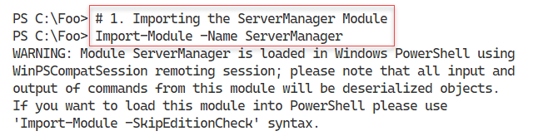
Figure 2.2: Importing the Server Manager module.
Insert image B18878_02_02.png
In step 2, you the Get-Module command to examine the Server Manager module’s properties. The output of this step looks like this:
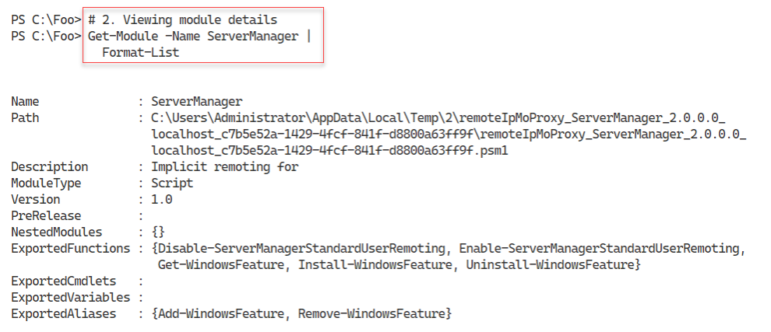
Figure 2.3: Importing the Server Manager module.
Insert image B18878_02_03.png
Now that you have loaded the Server Manager module, in step 3, you utilize one of the commands Get-WindowsFeature to view the details of a feature, with output like this;
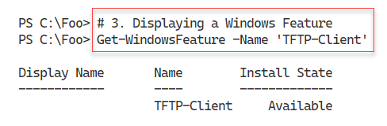
Figure 2.4: Displaying the TFTP-Client feature

Insert image B18878_02_04.png
In step 4, by comparison, you run the same command inside the Windows PowerShell remoting session with slightly different results – like this:
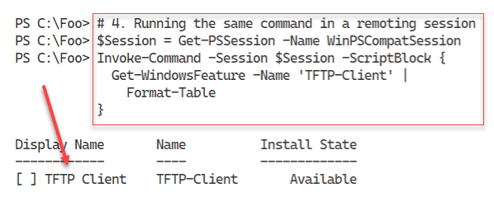
Figure 2.5: Displaying the TFTP-Client feature inside the remoting session
Insert image B18878_02_05.png
With step 5, you determine and display the folder where Windows PowerShell modules can be found, with output like this:
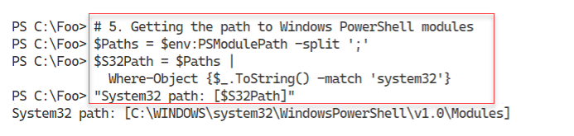
Figure 2.6: Displaying the TFTP-Client feature inside the remoting sessiohn
Insert image B18878_02_06.png
In step 6, you find and display the Server Manager’s display formatting XML file, with output like this:
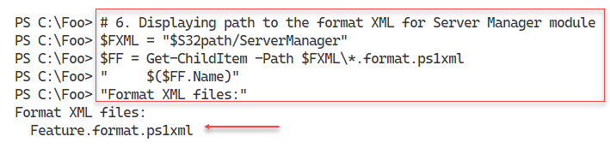
Figure 2.7: Displaying the TFTP-Client feature inside the remoting sessiohn
Insert image B18878_02_07.png
In step 7, you import the display XML files – which produces no output. Finally, in step 8, you re-run the Get-WindowsFeature command. Since you have now imported the necessary display XML, you see output like this:
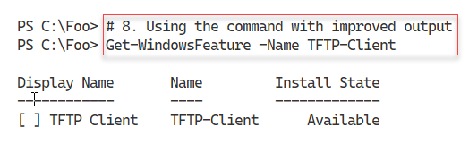
Figure 2.8: Displaying the TFTP-Client feature inside PowerShell 7 session
Insert image B18878_02_08.png

There's more...
In step 3, you used the Get-WindowsFeature to view one feature. When you run this command, PowerShell runs the command in the compatibility session and returns the object(s) for display in the PowerShell 7. However, as you may notice, the output is not the same as you would see, normally, in Windows PowerShell. This is because the Windows PowerShell compatibility does not, by default, add the formatting XML to the current PowerShell session.
Once you have loaded the Server Manager’s display XML, as you can seed in step 8, running the Get-WindowsFeature command now produces the same nicely formatted output you can see in Windows PowerShell.

Installing RSAT Tools
The Remote Server Admin Tools (aka RSAT) is a set of management tools you use to manage individual Windows Features. The RSAT tools are fundamental to administering the roles and features you can install on Windows Server. The Windows Server DNS Server feature, for example, comes with both an MMC console and a module that you use to manage the DNS Server on a given host. A nice thing about the commands in the ServerManager module – everything is a feature, meaning you do not know whether the tools manage a Windows Feature or a Windows Role.
Each feature in Windows Server can optionally have management tools, and most do. These tools can include PowerShell cmdlets, functions, aliases, GUI Microsoft Management Console (MMC) files, and Win32 console applications. The DNS Server’s RSAT tools include a PowerShell module, an MMC console as well as the command line tool dnscmd.exe. While you probably do not need the console applications since you can use the cmdlets, that is not always the case. And you may have some older batch scripts that use those console applications.
You can also install the RSAT tools independently of a Windows Server feature on Windows Server. This recipe covers RSAT tool installation on Windows Server 2019.
You can also install the RSAT tools in Windows 10 and administer your servers remotely. The specific method of installing the RSAT tools varies with the specific version of Windows 10 you are using. For earlier Windows 10 editions, you can download the tools here: https://www.microsoft.com/en-gb/download/details.aspx?id=45520.
In later editions of Windows 10, beginning with the Windows 10 October Update, you install the RSAT tools using the “Features on Demand” mechanism inside Windows 10. The URL in the previous paragraph has fuller details of how to install the RSAT tools on Windows 10.
As mentioned, PowerShell 7 is not installed in Windows by default, at least not at the time of writing. The PowerShell team made PowerShell 7.1 available from the Microsoft Store, which is useful to install PowerShell 7.1 or later on Windows 10/11 systems. Windows Server does not6 support the Microsoft store.
You have other methods of installing PowerShell 7 on your systems. The first option is to use the Install-PowerShell.ps1, which you download from GitHub, as shown in this recipe. You can also use this recipe on Windows 10 hosts. This approach has the advantage of being the most up-to-date source of the latest versions of PowerShell.

Getting ready
This recipe uses SRV1, a Windows Server workgroup host. There are no Windows features or server applications loaded on this server.

How to do it...

- Displaying counts of available PowerShell commands

$CommandsBeforeRSAT = Get-Command
$CmdletsBeforeRSAT = $CommandsBeforeRSAT |
Where-Object CommandType -eq 'Cmdlet'
$CommandCountBeforeRSAT = $CommandsBeforeRSAT.Count
$CmdletCountBeforeRSAT = $CmdletsBeforeRSAT.Count
"On Host: [$(hostname)]"
"Commands available before RSAT installed [$CommandCountBeforeRSAT]"
"Cmdlets available before RSAT installed [$CmdletCountBeforeRSAT]"

- Getting command types returned by Get-Command

$CommandsBeforeRSAT |
Group-Object -Property CommandType

- Checking the object type details

$CommandsBeforeRSAT |
Get-Member |
Select-Object -ExpandProperty TypeName -Unique

- Getting the collection of PowerShell modules and a count of modules before adding the RSAT tools

$ModulesBefore = Get-Module -ListAvailable

- Displaying a count of modules available before adding the RSAT tools

$CountOfModulesBeforeRSAT = $ModulesBefore.Count
"$CountOfModulesBeforeRSAT modules available"

- Getting a count of features actually available on SRV1

Import-Module -Name ServerManager -WarningAction SilentlyContinue
$Features = Get-WindowsFeature
$FeaturesI = $Features | Where-Object Installed
$RsatF = $Features |
Where-Object Name -Match 'RSAT'
$RSATFI = $RSATF |
Where-Object Installed

- Displaying counts of features installed

"On Host [$(hostname)]"
"Total features available [{0}]" -f $Features.count
"Total features installed [{0}]" -f $FeaturesI.count
"Total RSAT features available [{0}]" -f $RSATF.count
"Total RSAT features installed [{0}]" -f $RSATFI.count

- Adding all RSAT tools to SRV1

Get-WindowsFeature -Name *RSAT* |
Install-WindowsFeature

- Getting Details of RSAT tools now installed on SRV1

FSRV1A = Get-WindowsFeature
$IFSRV1A = $FSRV1A | Where-Object Installed
$RSFSRV1A = $FSRV1A | Where-Object Installed |
Where-Object Name -Match 'RSAT'

- Displaying counts of commands after installing the RSAT tools

"After Installation of RSAT tools on SRV1"
"$($IFSRV1A.count) features installed on SRV1"
"$($RSFSRV1A.count) RSAT features installed on SRV1"

- Displaying RSAT tools on SRV1

$MODS = "$env:windir\system32\windowspowerShell\v1.0\modules"
$SMMOD = "$MODS\ServerManager"
Update-FormatData -PrependPath "$SMMOD\*.format.ps1xml"
Get-WindowsFeature |
Where-Object Name -Match 'RSAT'

- Rebooting SRV1 then logging on as the local administrator

Restart-Computer -Force

How it works...
In step 1, you use Get-Command to obtain all the existing commands available on SRV1. Then you create a count of the commands available as well as a count of the PowerShell cmdlets available to you, with output like this:

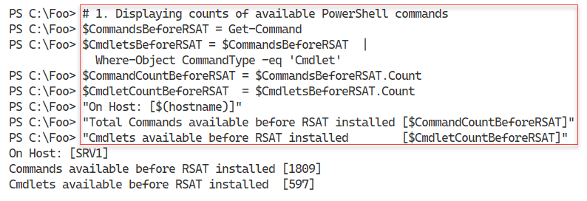
Figure 1.9: Counting the available commands and cmdlets on SRV1
Insert image B18878_02_09.png
In step 2, you discover the different kinds of commands returned by Get-Command. The output looks like this:
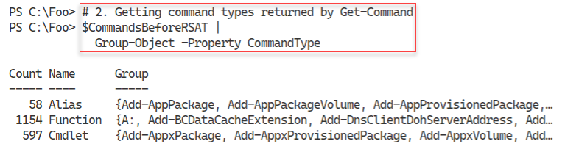
Figure 1.10: Viewing command types returned by Get-Command
Insert image B18878_02_10.png
In PowerShell, the Get-Command cmdlet returns occurrences of different object types to describe the available commands. As you saw in the previous step, there are three command types returned by default by Get-Command. There is a fourth command type, Application, which Get-Command does not return by default. You can see the class names for those three command types in the output from step 3, which looks like this:
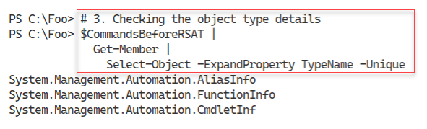
Figure 1.11: Determining full object type names
Insert image B18878_02_11.png
In step 4, you get the modules available on SRV1, which returns no console output. In step 5, you display a count of the modules discovered, with output like this:
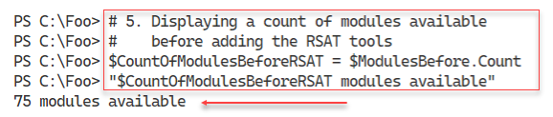
Figure 1.12: Displaying the number of modules available
Insert image B18878_02_12.png
In step 6, you obtain a count of the features available on SRV1, which produces no output. In the following step, step 7, you display counts of the total features available and the number of RSAT tool sets available. The output from this step looks like this;
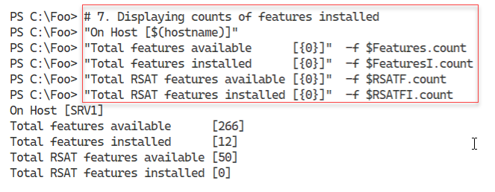
Figure 1.13: Displaying the number of features and RSAT features available
Insert image B18878_02_13.png
In step 8, you install all the available features onto SRV1, with output like this:
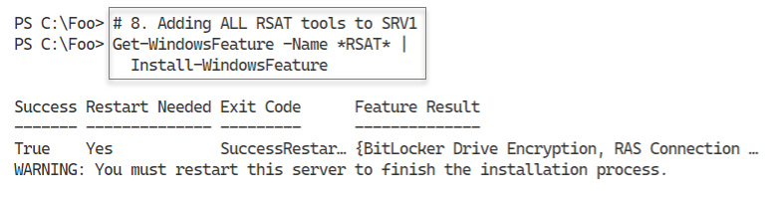
Figure 1.14: Adding all RSAT tools to SRV1
Insert image B18878_02_14.png
In step 9, you get details of all the features now available on SRV1, producing no output. In step 10, you obtain and display a count of the features, including RSAT features, on SRV1, with output like this:
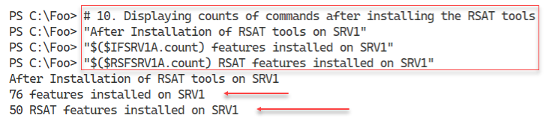
Figure 1.15: Counting features and RSAT features
Insert image B18878_02_15.png
In step 11, you use Get-WindowsFeature to display all the RSAT tools and their installation status, with output like this:
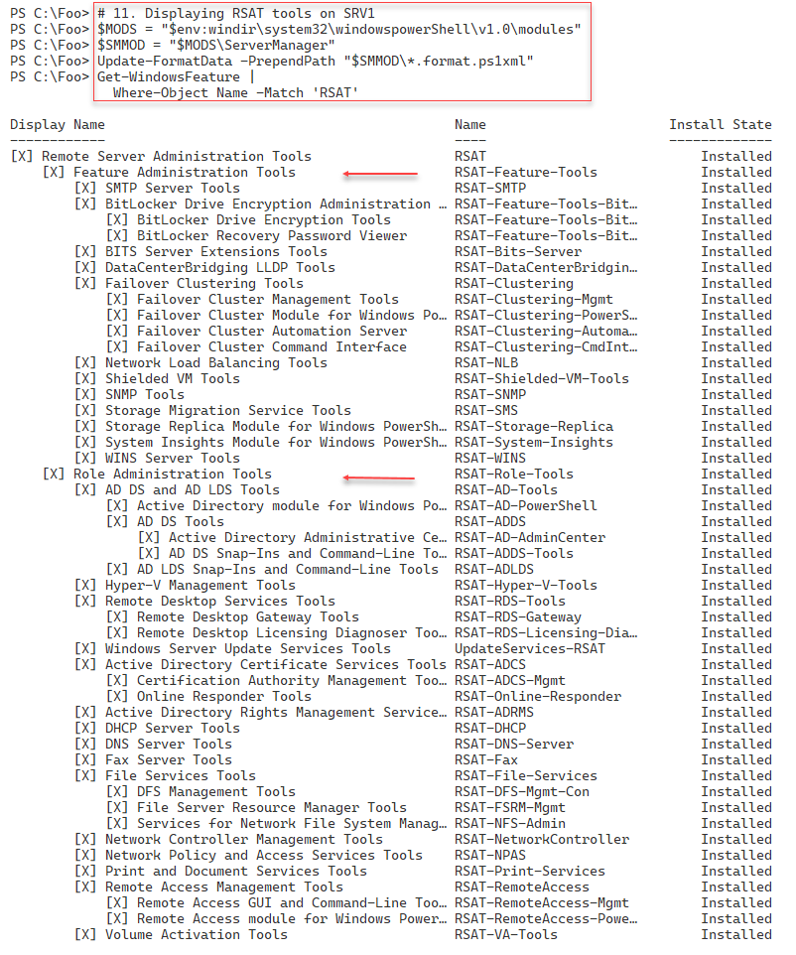
Figure 1.16: Displaying RSAT features on SRV1
Insert image B18878_02_16.png

In the final step in this recipe, step 12, you reboot the host creating no console output.

There's more...
The output from step 1 shows there are 1809 total commands and 597 cmdlets available on SRV1, before adding the RSAT tools. The actual number may vary, depending on what additional tools, features, or applications you might have added to SRV1 or the specific Windows Server version.
In step 2 and step 3, you find the kinds of commands available and the object type name PowerShell uses to describe these different command types. When you have the class names, you can use your search engine to discover more details about each of these command types. There are two further types of command (ExternalScript and Application) but these are not returned by default.
In step 8, you install all RSAT tools and as you can see, Windows requires a reboot to complete the installation of the tools. Later, in step 12, you reboot SRV1 to complete the installation of these tools.
In step 11, you display all the RSAT tools using Get-WindowsFeature. Strictly speaking, this step displays the Windows features that have “RSAT” somewhere in the feature name. As you can see, there is no standard for actual feature names. The output shows the individual tools as either Feature Administration Tools or Role Administration tools although that difference is not relevant in your using the Server Manager cmdlets.

Exploring Package Management
The PackageManagement PowerShell module provides tools that enable you to download and install software packages from a variety of sources. The module, in effect, implements a provider interface that software package management systems use to manage software packages.
You can use the cmdlets in the PackageManagement module to work with a variety of package management systems. This module, in effect, provides an API to package management providers such as PowerShellGet, discussed in the “Exploring PowerShellGet and PS Gallery” recipe.
The primary function of the PackageManagement module is to manage the set of software repositories in which package management tools can search, obtain, install, and remove packages. The module enables you to discover and utilize software packages from a variety of sources, including the PowerShell Gallery.
The modules in the various Internet repositories, including the PowerShell Gallery, vary in quality. Some are excellent and are heavily used by the community, while others are less useful or of lower quality. Some are written by the PowerShell product team. Ensure you look carefully at any third-party module you put into production.
This recipe explores the PackageManagement module from SRV1.

Getting ready
You run this recipe on SRV1 after you have installed PowerShell 7.

How to do it...
- Reviewing the cmdlets in the PackageManagement module

Get-Command -Module PackageManagement

- Reviewing installed providers with Get-PackageProvider

Get-PackageProvider |
Format-Table -Property Name,
Version,
SupportedFileExtensions,
FromTrustedSource

- Examining available Package Providers

$PROVIDERS = Find-PackageProvider
$PROVIDERS |
Select-Object -Property Name,Summary |
Format-Table -AutoSize -Wrap

- Discovering and counting available packages

$PACKAGES = Find-Package
"Discovered {0:N0} packages" -f $PACKAGES.Count

- Showing the first 5 packages discovered

$PACKAGES |
Select-Object -First 5 |
Format-Table -AutoSize -Wrap

- Installing the ChocolateyGet provider

Install-PackageProvider -Name ChocolateyGet -Force |
Out-Null

- Verifying ChocolateyGet is in the list of installed providers

Import-PackageProvider -Name ChocolateyGet
Get-PackageProvider -ListAvailable |
Select-Object -Property Name,Version

- Discovering Packages using the ChocolateyGet provider

$CPackages = Find-Package -ProviderName ChocolateyGet -Name *
"$($CPackages.Count) packages available via ChocolateyGet"

How it works...
In step 1, you use Get-Command to discover the cmdlets in the PackageManagement module, with output like this:
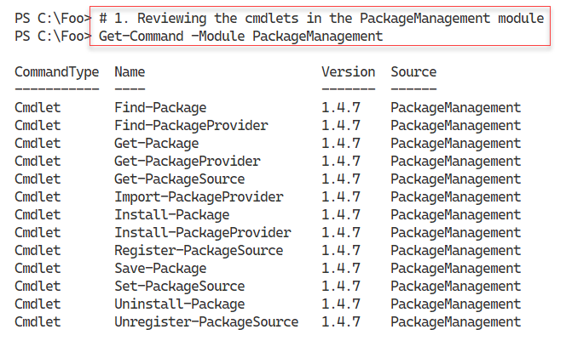
Figure 1.17: The PowerShell 7 console
Insert image B42024_01_17.png
In step 2, you use the Get-PackageProvider cmdlet to view the package providers that you have loaded and imported, with output like this:
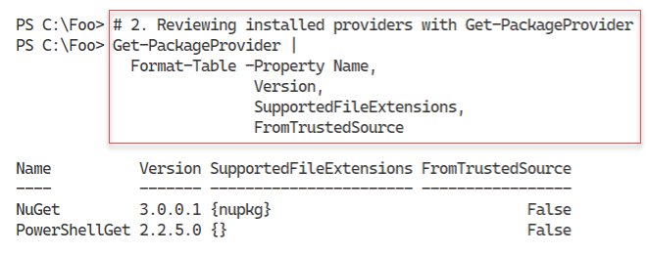
Figure 1.18: Reviewing installed package providers
Insert image B42024_01_18.png
In step 3, you use the Find-PackageProviders cmdlet to find additional package providers. The output looks like this:
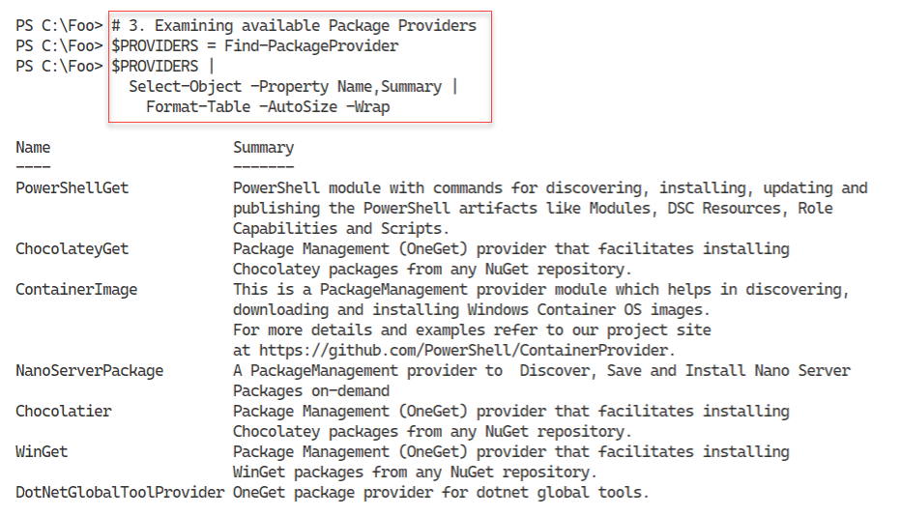
Figure 1.19: Discovering additional package providers
Insert image B42024_01_19.png
You can use the Find-Package cmdlet to discover packages which you can download, install, and use. In step 4, you discover packages available with output that resembles this:
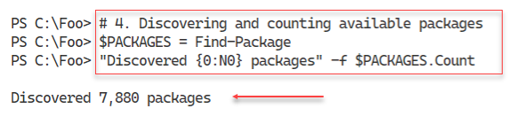
Figure 1.20: Counting available packages
Insert image B42024_01_20.png
In step 5, you view the details of five (the first five) packages you discovered in the prior step. The output looks like this:
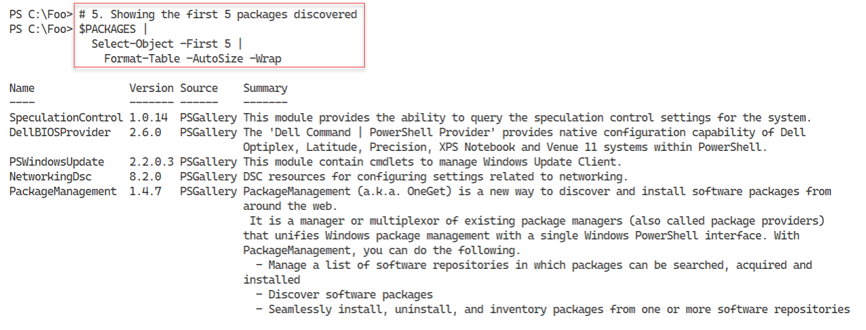
Figure 1.21: Viewing package summaries
Insert image B42024_01_21.png
In step 6, you install a new package provider – the ChocolateyGet provider. This step produces no output. In step 7, you view the currently imported package providers, with output like this:
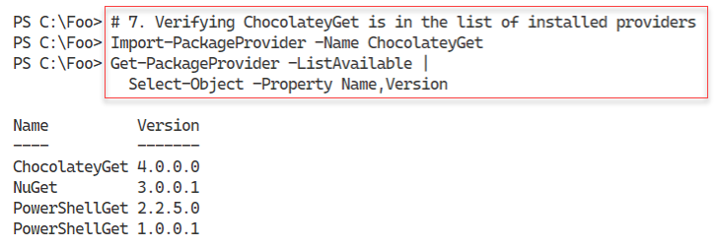
Figure 1.22: Viewing package summaries
Insert image B42024_01_22.png
In the final step in this recipe, step 8, you discover all the currently available packages you can download using the ChocolatelyGet package provider – the output looks like this:

Figure 1.23: Counting packages available via the ChocolateyGet provider
Insert image B42024_01_23.png

There's more...
In step 1, you open a new Windows PowerShell console. Make sure you run the console as the local administrator

In step 4, you display a count of the packages available in the PS Gallery. It is highly likely that the number you see when you run this has changed (i.e. increased). Package authors in the community are constantly adding new and improved packages to the PS Gallery. At the same time, since some users may have developed some automation on top of older providers, these too remain in the PS Gallery.
In step 7, you install the ChocolateyGet packaged provider. With this provider, you can discover and install packages from the Chocolatey repository in addition to the PowerShell gallery. In chapter 1, you installed the Chocolatey command-line tool – in step 8, you find packages using the Find-Package cmdlet. The PowerShell Gallery and Chocolatey have many packages in common so you can probably find whatever packages you might need in either or both.

Exploring PowerShellGet and the PS Gallery
PowerShellGet is a module that enables you to discover, install, update, and publish key PowerShell artifacts. The module makes use of the online PowerShell Gallery. The artifacts you can leverage include modules, scripts, and more. You can read more about the module at: https://docs.microsoft.com/powershell/module/powershellget.

Getting ready
You run this recipe on SRV1 after you have installed PowerShell 7.

How to do it...

- Running the PowerShell 7 console

How it works...
In step 1, you start the PowerShell 7 console on SRV1. The console should look like this:
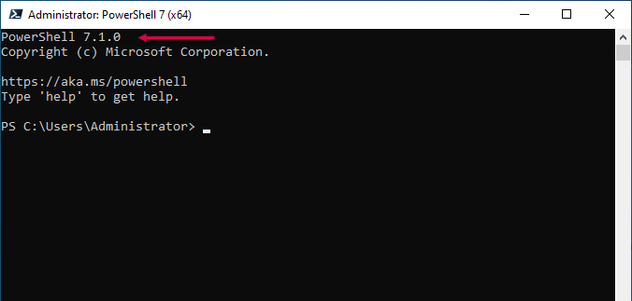
Figure 1.5: The PowerShell 7 console
Insert image B42024_01_05.png
In

There's more...
In step 1, you open a new Windows PowerShell console. Make sure you run the console as the local administrator

Creating and using a local package repository
Chocolatey is a third party package management tool for Windows. You can read more about ther company and its products at https://chocolatey.org/. Chocolatey has a very large online registry of Windows packagres which you can easily install. This can simplify deployment of applications in your environment.

Getting ready
You run this recipe on SRV1 after you have installed PowerShell 7.

How to do it...

- Running the PowerShell 7 console

How it works...
In step 1, you start the PowerShell 7 console on SRV1. The console should look like this:
Figure 1.5: The PowerShell 7 console
Insert image B42024_01_05.png
In

There's more...
In step 1, you open a new Windows PowerShell console. Make sure you run the console as the local administrator

Establishing a Code signing environment
Chocolatey is a third party package management tool for Windows. You can read more about ther company and its products at https://chocolatey.org/. Chocolatey has a very large online registry of Windows packagres which you can easily install. This can simplify deployment of applications in your environment.

Getting ready
You run this recipe on SRV1 after you have installed PowerShell 7.

How to do it...

- Running the PowerShell 7 console

How it works...
In step 1, you start the PowerShell 7 console on SRV1. The console should look like this:
Figure 1.5: The PowerShell 7 console
Insert image B42024_01_05.png
In

There's more...
In step 1, you open a new Windows PowerShell console. Make sure you run the console as the local administrator

Working with shortcuts and the PSShortCut module
Chocolatey is a third party package management tool for Windows. You can read more about ther company and its products at https://chocolatey.org/. Chocolatey has a very large online registry of Windows packagres which you can easily install. This can simplify deployment of applications in your environment.

Getting ready
You run this recipe on SRV1 after you have installed PowerShell 7.

How to do it...

- Running the PowerShell 7 console

How it works...
In step 1, you start the PowerShell 7 console on SRV1. The console should look like this:
Figure 1.5: The PowerShell 7 console
Insert image B42024_01_05.png
In

There's more...
In step 1, you open a new Windows PowerShell console. Make sure you run the console as the local administrator

Working with Archive files
Chocolatey is a third party package management tool for Windows. You can read more about ther company and its products at https://chocolatey.org/. Chocolatey has a very large online registry of Windows packagres which you can easily install. This can simplify deployment of applications in your environment.

Getting ready
You run this recipe on SRV1 after you have installed PowerShell 7.

How to do it...

- Running the PowerShell 7 console

How it works...
In step 1, you start the PowerShell 7 console on SRV1. The console should look like this:
Figure 1.5: The PowerShell 7 console
Insert image B42024_01_05.png
In

There's more...
In step 1, you open a new Windows PowerShell console. Make sure you run the console as the local administrator

Searching for files using Search Everything
Chocolatey is a third party package management tool for Windows. You can read more about ther company and its products at https://chocolatey.org/. Chocolatey has a very large online registry of Windows packagres which you can easily install. This can simplify deployment of applications in your environment.

Getting ready
You run this recipe on SRV1 after you have installed PowerShell 7.

How to do it...

- Running the PowerShell 7 console

How it works...
In step 1, you start the PowerShell 7 console on SRV1. The console should look like this:
Figure 1.5: The PowerShell 7 console
Insert image B42024_01_05.png
In

There's more...
In step 1, you open a new Windows PowerShell console. Make sure you run the console as the local administrator

